Operating Systems Activity: Team Challenge - Date: 10.10.2026

Topics: Process Concepts and Process Scheduling
1. Activity Overview
- Activity Name: Team Challenge – Process Scheduling Masters
- Subject: Operating Systems
- Duration: 40–50 minutes
- Team Size: 4–5 students per team
- Objective: To help students understand process states, Process Control Blocks (PCBs), scheduling algorithms, Gantt charts, waiting time, turnaround time, and CPU utilization through collaborative problem-solving.
Round 1: Process Concept Quiz
5 minutes
Each team answers questions about process concepts.
- What is the difference between a program and a process?
- What information is stored in a PCB?
- What happens when a running process requests I/O?
- What is a context switch?
- Can a process move directly from Running to Ready? Explain.

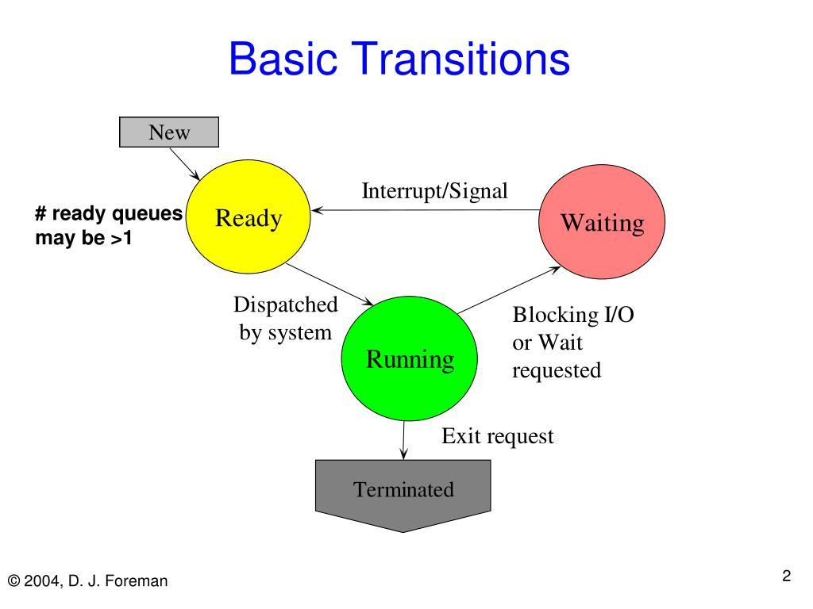
Round 2: Scheduling Algorithm Challenge
15 minutes
Each team solves a CPU scheduling problem, draws the Gantt chart, and calculates average waiting and turnaround times.
Teams can be assigned FCFS, SJF, SRTF, or Round Robin scheduling.

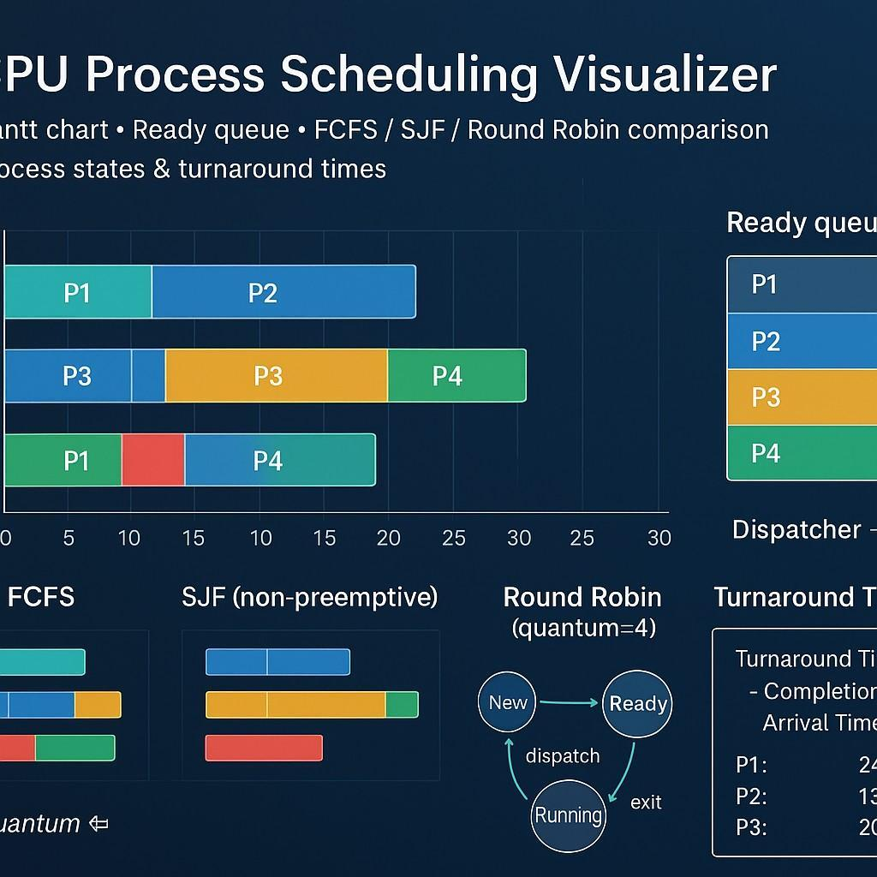

Round 3: Find the Error
10 minutes
Teams identify and correct errors in process scheduling statements and calculations.
Example: A team claims that a process with the shortest burst time must always execute first, regardless of its arrival time. Is the statement correct?




